1.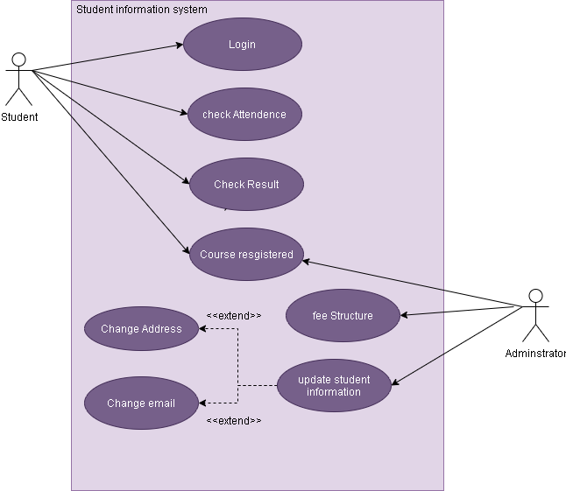.

a) Student Must be Login FIRST

b) Student Can Check there attendence

c) Student can check result

d) Course registered can be access by both student and adminstrator

e) Adminstrator can access the fees structure

f) Adminstrator can update information of the student

g) Update information extend mean it can be change address

it is not necessary or administrator can change student email address